# Misc.

Radio buttons - Radio buttons are selectors used for the list of two or more options, and all options in this list are mutually exclusive. Users must select exactly one option. When users click on a non-selected radio button, it will deselect whatever other option was previously selected in the list. Radio buttons always have exactly one option selected. You should never display radio buttons without a default selection. Using guidelines for radio buttons

- Use radio buttons when all options in the list have the same weight. There is an equal possibility that the user can choose any option from the list.

- Provide option "None" or "None of them" if users might want to refrain from making a selection. Never force users to choose the option they don’t want to choose.

- Try to avoid the horizontal arrangement of radio buttons. Horizontal radio buttons can be difficult to scan — it can be challenging for users to tell which label the radio button corresponds to.

- Downsides of using radio buttons

- Take screen estate. Each option takes a row on the screen. It might be a problem for mobile screens.

- Can be ignored by users. Since radio buttons always come with one option pre-selected, users might simply ignore it. They might assume that the system already chooses the best possible option for them.

Checkboxes - A checkbox can be a single option or a set of options available for selection. Checkboxes are used when the user may select any number of choices, including zero, one, or several. Each checkbox in the set is independent of all other checkboxes, so checking one box doesn’t do anything to the others. Benefits of using checkboxes - Checkboxes expose all available options. Users can see all available options at a glance and make a selection. Downsides of using checkboxes - Take screen estate. Each option takes a row on the screen. It might be a problem for mobile screens that have limited screen estate. Using guidelines for checkboxes

- Use positive and active wording for labels. It will help users understand what will happen if they turn on the checkbox.

Toggle switch - Switch prompts users to choose between two mutually exclusive options and always has a default value. It works well when users have to answer Yes/No questions and for binary operations (such as enabling or disabling a particular setting). Toggle is easier for the thumb. This property makes it suitable for mobile devices. Using guidelines for toggle switch

- Toggles should provide immediate results. They should not require the user to click Save/Submit button to apply the new state.

Dropdown - Dropdown is a list of options that become visible when the user clicks on the input box. This control is typically used for a long list of options (i.e., 6 or more). Benefits of using dropdown lists - Dropdown saves screen estate. It uses less space because all options become visible only when the user presses the Select button. Using guidelines for dropdown

- Dropdowns should be the last resort. Whenever possible, instead of dropdown, try to use alternative controls that help the user to complete the task but have better usability.

# Interaction Design: The Big Picture

Interaction Design (IxD) – the process of designing interactive products, focusing on how users will interact with them. sometimes called “conversations design”.

IxD is a subset of UxD (user experience design).

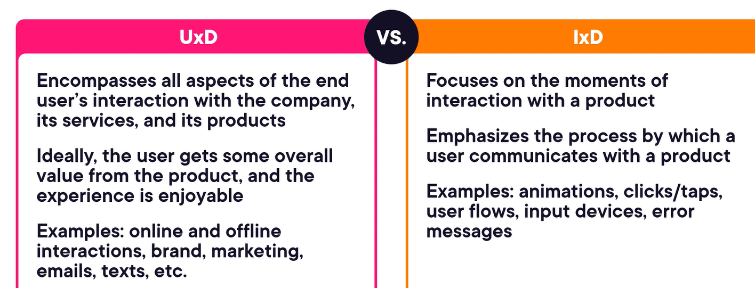

Interaction design dimensions – words, visual representations, physical objects or space, time, behavior.

Techniques used in interactions design –

